No More Penicillin: A Future Without Antibiotics?

Kelvin Li ‘21

**INTRODUCTION**

The invisible world of microbes is a scary place. For nearly the entirety of humanity’s existence, infectious diseases have been the leading cause of death. It wasn’t until recently that developments such as antiseptic chemicals, vaccinations, and pasteurization (to name a few) were developed to combat lethal pathogens. Because of those advances, life expectancy and global population levels have skyrocketed in the past century, but there is one advance that has caused the death toll from bacterial infections has all but disappeared. That advance is the development of antibiotics, small molecules designed to inhibit or kill bacteria.

To take a page out of the 2008 financial crisis, the variety of antibiotics discovered in the 1950s and 1960s seemed “too big to fail.” Unfortunately, medicine is now growing closer to the point where all currently used antibiotics will succumb to resistance. In the direst of cases, humanity will plunge back into a pre-antibiotics era. That’s not to say there is no hope though; there are several promising new drugs in the pipeline that look to be effective in killing even the most resistant bacteria. If this research can be sustained and if policy changes can be enacted to promote responsible antibiotic usage, then the resistance problem will effectively be solved.

**THE BIOCHEM PROBLEM**

The antibiotic revolution has afforded great benefits to humanity including a vast increase in life expectancy, the disappearance of many fatal infections, control over other once deadly viral diseases, and even increased crop and animal yield.1 Yet in the euphoria of having momentarily defeated bacterial infections, scientists forgot how adaptable bacteria are in their ability to process their chemical surroundings. The so called “golden age” of antibiotics resulted in thousands of new compounds produced by selectively modifying natural antibiotics (such as amoxicillin from penicillin) and this seemingly endless supply was thought to be enough to stave off resistance.1 What followed, however, was a dramatic decrease in discovery of antibiotics due to growing research costs and stagnating technical screening and isolation strategies.1 And even though research has increased in recent years, without financial backers to develop these compounds into usable drugs, there is still a frustratingly low number of new drugs entering the market.

For many drugs, a slow discovery process would not be problematic, but for antibiotics, science is racing against the evolutionary clock driving resistance. The World Bank has estimated costs of bacterial resistance could be even more than the 2008 recession,2 and the CDC has estimated over 23,000 deaths in over 2 million antibiotic resistant infections in the last year alone with that number only projected to rise.3 Naturally occurring resistant bacteria are normally evolutionarily disadvantaged because of the metabolic costs of maintaining resistant mechanism and thus are found in low concentrations in the environment. However, following introduction of antibiotics, the non-resistant individuals are killed, and resistant organisms are allowed to proliferate.3 Not only can these resistant colonies go on to cause infections directly, they can transfer their resistance genes to other bacteria, sometimes of completely different species, furthering the spread of resistance.3 Scientists knew this all but underestimated the speed at which bacteria could adapt which is what led them to this current crisis.1

Of the resistant bacteria, the most pressing subset are the Gram-negative species, a categorization based on structural differences in bacteria. A useful analogy might be to think of Gram-positives as being surrounded by a thick layer of steel mesh while Gram-negatives are surrounded by a thin layer of lead. Throwing a rock at both will not do anything, however, pouring water on the Gram-positives will allow penetration. In addition to the decreased permeability to drugs, Gram-negatives also have more built in resistance mechanisms and a higher ability to pass genes around.5 Thus, antibiotic resistant Gram-negatives are causing more infections worldwide and those infections are more difficult to treat as well.2

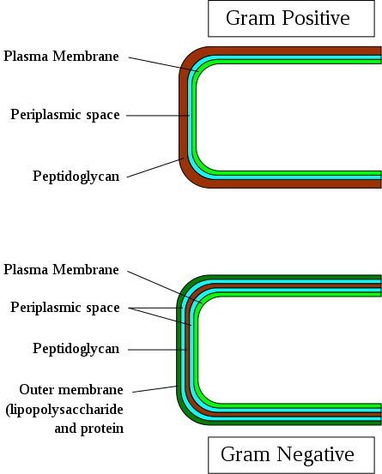

Figure 1

https://commons.wikimedia.org/wiki/File:Gram-Cell-wall.svg

**THE INDUSTRY PROBLEM**

The last, and arguably most concerning, obstacle in solving the resistance problem concerns industrial pressures. As antibiotics ideally should be used as sparingly as possible, that creates an unfavorable situation for pharmaceutical companies looking to maximize sales which results in research on antibiotics being relegated to academia.1 Additionally, since antibiotics cure diseases, they are short course therapies and thus bring in less revenue than say a beta-blocker for high blood pressure which must be constantly taken. Lastly, the time and money it takes to develop new antibiotics (even longer and more expensive now that drug-approval protocols have become more stringent) combined with the short time frame is just an additional factor making it unfavorable for drug companies, or anyone for that matter, to invest in antibiotic development.1

Promisingly though, there has been a rather unprecedented uptick in global awareness of antibiotic resistance and a number of entities have implemented programs designed to incentivize research and development.2

**THE PRIORITY ANTIMICROBIAL VALUE AND ENTRTY (PAVE) AWARD**

The PAVE award concept, developed by the Duke-Margolis Center for Health Policy at Duke University, aims to overcome the low return on investment of antibiotics and overturn the current volume-based payment industry paradigm.5 They proposed a market entry award which will provide companies with public funding following FDA approval with the stipulation that they must find other sources of funding that are tied to drug efficacy/performance.5,6 To generate these public funds, the group considered selling transferable exclusivity vouchers (TEV) which when owned, would allow companies to maintain a limited monopoly on a drug of their choice.

Though not expressly included as part of the award, the PAVE group recommended that a comprehensive strategy for addressing antibiotic resistance should also include what they call “push incentives.”5 Push incentives do what their name implies, they push drugs into the market by providing funds for both clinical and pre-clinical research, reducing the burden of the drug approval process on pharmaceutical companies. Thus, they increase both academic and industry research and speed up the discovery and safety testing steps of drug development.

The PAVE award stresses that financial incentives for pharmaceutical companies alone, no matter the amount and no matter the time line over which they are given, will not be enough to defeat resistance. They stress that proper antibiotic stewardship, minimizing unnecessary antibiotic usage and prescribing the minimally effective antibiotic for a given infection, will also be key.5 This responsibility will have to lie primarily on doctors and other health professions as they have direct contact with patients, but the PAVE award makes it clear that the industry must also stop pushing for their antibiotics to be prescribed.

**FDA PROGRAMS**

The USA’s FDA has created a variety of programs designed to increase the amount of antibiotics available to treat resistant infections. As part of their GAIN (Generating Antibiotic Incentives Now) act, the FDA created the QIDP (Qualified Infectious Disease Product) designation which offers the incentive of a five-year exclusivity extension and both Fast Track designation and priority review from the FDA.7 QIDP status allows drugs to make it through the FDA’s review process much quicker and also gives them access to more guidance from the FDA in the process to approval.7

A similar program to the FDA’s Fast Track process is the Breakthrough Therapy designation. It is not included with QIDP designation, and to receive the designation, a drug must show that it has a clear advantage over available therapy, examples of which include improved safety profile or an effect on serious symptoms of a disease.8 Breakthrough Therapy designation includes all the benefits of the Fast Track process but also includes more thorough advising on efficient drug development starting in Phase 1 clinical trials.8

**UPCOMING DRUGS**

In conjunction with the industry modifying policies spurring research and changing antibiotic usage paradigms to prevent future development of resistance, new drugs still need to be developed which can deal with the current resistance problem. For now, there are only a few candidates that have shown promise in fighting multi-drug resistant Gram-negative bacteria, but even one reliable drug is enough to start making a dent in the problem. Some of them are semisynthetic derivatives of known drugs, some are fully synthetic compounds of established antibiotics classes, some of the drugs are new combinations of previously approved drugs, and others are completely new classes of compounds. Here is an overview of a few of the upcoming drugs.

**Lefamulin**

A novel pleuromutilin, lefamulin is being developed by Nebriva and currently in Phase 3 clinical trials.9 Interestingly enough, it is the first pleuromutilin to be developed for systemic rather than topical use which has made it incredibly effective against many drug resistant bacteria both Gram-negative and positive.9,10 Additionally, research has shown that pleuromutilins have a generally low susceptibility to resistance development and that due to their unique mechanism of action, they have low levels of cross resistance with other antibiotics.10,11 Though it is currently being advanced as an agent to treat community acquired bacterial pneumonia (CABP), Nabriva is also developing it for skin infections and pediatric infections all in both IV and oral availabilities.10

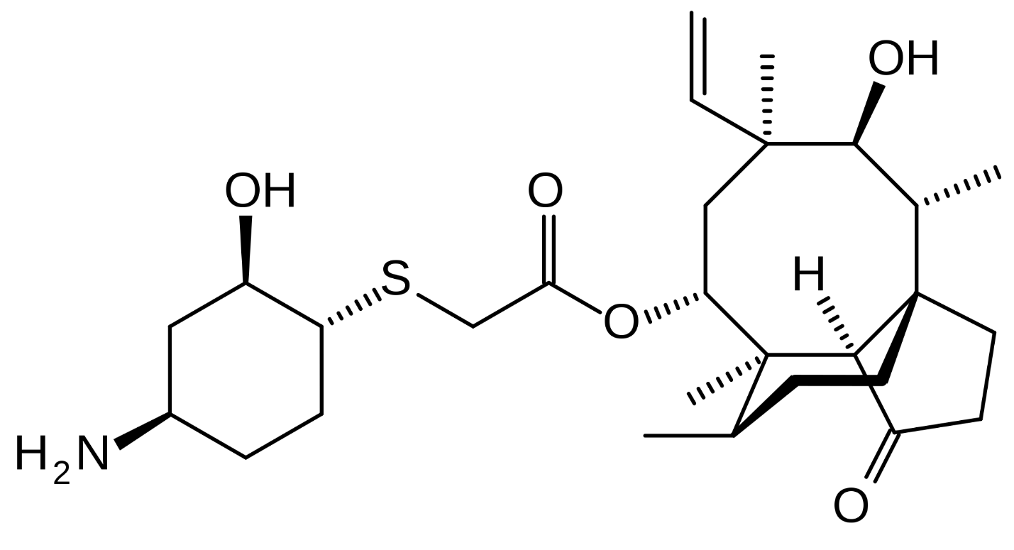

Figure 2

https://commons.wikimedia.org/wiki/File:Lefamulin_skeletal.svg

**Eravacycline**

Synthesized at Harvard University by Amory Houghton Professor of Chemistry and Chemical Biology Andrew Myers, eravacycline is a tetracycline antibiotic that was developed to treat complicated intra-abdominal infections (cIAI).12 The fully synthetic route to its creation allowed for substitution of chemical structures that were key in demonstrating activity against CRE and carbapenem resistant A. Baumanii (CRAB).9,12 It is also unaffected by many resistant mechanisms specific to tetracyclines and is effective against bacteria resistant to colistin, a potent drug of last resort.9,12 Tetraphase, its parent company, recently submitted an NDA which was given priority review and included data demonstrating non-inferiority to two carbapenems in Phase 3 clinical trials and is aiming for both IV and oral formulations of the drug to treat serious hospital infections.12

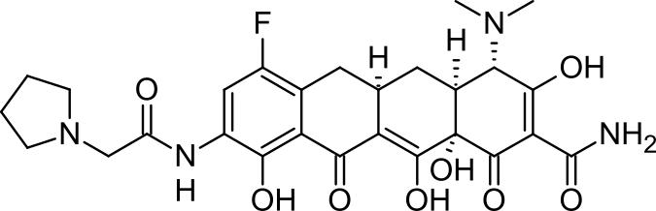

Figure 3

https://commons.wikimedia.org/wiki/File:Eravacycline-.png

**Cefiderocol**

Antibiotic resistance is not always due to degradation of the drug by bacterial enzymes. Sometimes the drugs simply cannot penetrate the cell either because they are actively effluxed or because the cell wall is simply too difficult to breach. To get around the latter, scientists at Shionogi have developed cefiderocol which is a semisynthetic derivative of ceftazidmine, a cephalosporin, and is able to get into bacterial cells by binding to iron and hitching a ride through the bacterial iron.9,13 Because of the novelty of the compound, it is relatively immune to all the known beta-lactamases and has demonstrated activity against all of the multi drug resistant Gram-negative infections prioritized by the WHO.13 Phase 3 clinical trials are currently being done or have been completed in cUTIs and in hospital/ventilator acquired pneumonia and Shionogi is planning on submitting a NDA later this year.9,13

**Murepavadin**

The first in its class of novel antibiotics, murepavadin is an outer membrane protein targeting antibiotic developed by Polyphor which inhibits the construction of a portion of the cell wall by mimicking the needed compound.9 As the first of its class, there are only intrinsically resistant bacteria for which murepavadin cannot physically reach the membrane; in other words, there are no biochemical resistance mechanisms that would impede its success and thus it shows no cross resistance with other antibiotics.9,14 It is being developed to specifically treat carbapenem resistant Pseudomonas and has been given QIDP status with two Phase 2 clinical trials indicating high treatment levels and low resistance development having been completed.14

**Recce 327**

Taking the membrane binding idea further, Recce pharmaceuticals has developed a membrane binding protein that causes the cell to burst from outward pressure.15 It is unique in that it indiscriminately attacks both Gram-negative and Gram-positive bacteria because it is both effective against the outer membrane found in the Gram-negative bacteria and is small enough that it can diffuse through the thick peptidoglycan of the Gram-positive bacteria.15 Additionally, Recce claims that their product binds so nonspecifically to the cell wall that even mutations that alter the composition of its binding target won’t affect its efficacy.15 Having both broad spectrum and anti-resistant development characteristics would make this drug the ultimate addition to medicine’s arsenal, and having received QIDP designation from the FDA, recce is hoping that their planned clinical trials will be able to repeat the powerful results that laboratory experiments have demonstrated.15

**CONCLUSION**

Antibiotics have come a long way since the golden era of their discovery. Though in recent years bacteria have developed startling amounts of resistance to even the most potent of antibiotics, the world is starting to respond. With changes to both the research process and the prescribing paradigm and with increases in the development of novel antibiotics, science is on track to restore the benefits that the first antibiotic revolution brought about. As the public becomes increasingly aware of the problem of resistance, patients will undoubtedly reduce their want of unnecessary antibiotics; however, doctors and the industry must also do their part. Policy changes may be the ultimatum needed to spur action, but regardless, increased research into antibiotics will only be effective if everyone educates themselves about proper antibiotic stewardship. Antibiotics allowed for major surgeries lifesaving procedures that would have impossible due to the risk of infection and it is not an exaggeration to say that antibiotics form the cornerstone of many of the greatest medicinal advancements in the last half century. Continued enjoyment of their benefits will require work from pharmaceutical companies, doctors, and patients alike, but it is a worthwhile change that will undoubtedly continue to bring far reaching benefits to all of humanity.

Bio: Kelvin Li ’21 is a freshman in Wigglesworth Hall.

Works Cited

[1] Bérdy, J. Thoughts and Facts about Antibiotics: Where We are Now and Where We are Heading. *J Antibiot.* 2012, *65*, 385-389.

[2] WHO/EMP/IAU. Prioritization of Pathogens to Guide Discovery, Research and Development of New Antibiotics for Drug-resistant Bacterial Infections Including Tuberculosis; World Health Organization: Geneva, CH, 2017.

[3] About Antimicrobial Resistance. <https://www.cdc.gov/drugresistance/about.html> (accessed Feb. 18, 2018).

[4] Gram-negative Bacteria Infections in Healthcare Settings. <https://www.cdc.gov/hai/organisms/gram-negative-bacteria.html> (accessed Feb. 18, 2018).

[5] Daniel, G.W. *et al.* Value-based Strategies for Encouraging New Development of Antimicrobial Drugs; Duke Margolis Center for Health Policy: Washington, US-DC, 2017.

[6] Daniel, G.W. *et al.* Addressing Antimicrobial Resistance and Stewardship: The Priority Antimicrobial Value and Entry (PAVE) Award. *JAMA*. 2017, *318*, 1103-1104.

[7] FDA: CDER. Qualified Infectious Disease Product Designation Questions and Answers Guidance for Industry; Food and Drug Administration: Rockville, US-MD, 2018.

[8] Breakthrough Therapy. <https://www.fda.gov/ForPatients/Approvals/Fast/ucm405397.htm> (accessed Feb. 18, 2018).

[9] WHO/EMP/IAU. Antibacterial Agents in Clinical Development: An Analysis of the Antibacterial Clinical Development Pipeline, Including Tuberculosis; World Health Organization: Geneva, CH 2017.

[10] Pipeline and Research. <https://www.nabriva.com/pipeline-research> (accessed Feb. 18, 2018).

[11] Paukner, S.; Ridel, R. Pleuromutilins: Potent Drugs for Resistant Bugs – Mode of Action and r=Resistance. *Cold Spring Harb. Perspect. Med.* [Online] 2016, *7*, 83-98. <http://perspectivesinmedicine.cshlp.org/content/7/1/a027110> (accessed Feb. 18, 2018).

[12] Tetraphase Pharmaceuticals. Tetraphase Pharmaceuticals Announces Submission of New Drug Application to FDA for Eravacycline for the Treatment of Complicated Intra-Abdominal Infections (cIAI); Tetraphse Pharmaceuticals: Watertown, US-MA, 2018.

[13] Shionogi Incorporated. Shionogi Presents Positive Clinical Efficacy Trial Results And In Vitro Data On Cefiderocol, At IDWeek 2017; Shionogi & Co., Ltd.; Osaka, JP and Florham Park, US-NJ, 2018.

[14] Murepavadin (POL7080). <https://www.polyphor.com/pol7080/> (accessed Feb. 18, 2018).

[15] Product Candidates: Science. <https://www.recce.com.au/index.php/product-candidates/science> (accessed Feb. 18, 2018).